Suggested Mark Scheme

1 | Enzymatic browning is one of the most important colour reactions that affect fruits. Cut apples turned brown after exposure to air within minutes. This browning reaction is catalysed by the enzyme polyphenol oxidase (PPO) which is abundant in the flesh of the apples. PPO converts iron-containing phenol compounds in the presence of oxygen to melanin in a series of polymerization reactions.  Fig. 1.1 shows the structure of the PPO enzyme.  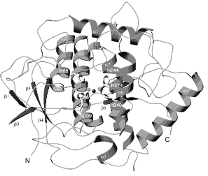  Fig. 1.1
 | (a) |  | With reference to Fig. 1.1, describe the structure of the PPO enzyme.
 |  |  | - globular protein consisting one polypeptide chain;;
 |  |  | - α helices and β pleated sheet held together by R group interactions;;
 |  |  | - Give at least 2 e.g. of R group interactions with details on type of R grps involved;; |  |  |  |  |  |  | [3]
 | (b) |  | Suggest the role of PPO in melanin synthesis in apples.
 |  |  | - active site with contact and catalytic residues specific for phenol cmpds;;
 |  |  | - E-S cplx formed stabalise transistion state/ allow formation of bonds btw polymers;; |  |  |  |  |  |  | [2]
Fig. 1.2 shows the results of tests to determine the optimum temperature for the activity of PPO.

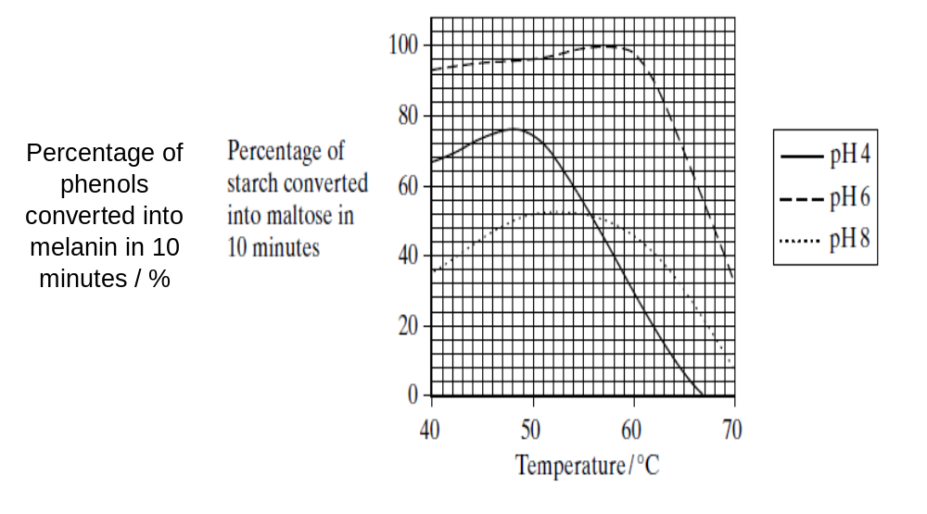

Fig. 1.2

 | (c) |  | With reference to Fig. 1.2,
 | (i) |  | state the optimum pH and temperature for the enzyme PPO.
 |  |  | pH |  | 6
 |  |  | temperature |  |  | 56 – 58ºC |  | [1]
 | (ii) |  | account for the curve at pH 8.
 |  |  | - lowest % of phenols converted @ 46% @ 50-55 ºC;;
 |  |  | - beyond opt pH, ionic & H-bonds disrupted due to á [OH-];;
 |  |  | - active sites unfolded, V complementary to substrates;;
 |  |  | - higher % converted compared to pH4, may be due to R grp interactions/stabilisation at higher temp;;
 |  |  | - 40-49 ºC,  in % conversion 36-53% due to  K.E.,  effective collisions between E and S;;
 |  |  | - optimum temp 50-56 ºC, max no. of E-S cplz @ 52%;;
 |  |  | -  beyond opt, at temp > 56 ºC to 70 ºC,  conversion from 52 to 8% due to breaking of H-bonds & hydrophobic interactions leading to enz denaturation, lost in active site;; |  |  |  |  |  |  | [3]
 |  |  | (MAX 3m)
 | [Total: 9]
2 | Fig. 2 is an electron micrograph showing T4 bacteriophages invading a bacterium.  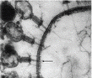  A  C  B  Fig. 2
 | (a) |  | Explain what is meant by the term bacteriophage.
 |  |  | - is a virus that specifically infects bacteria host cells;
 |  |  | - with ds DNA genome / may undergo lytic or lysogenic cycle / virulent ot temperate phage;
 |  |  | - are obligate intracellular parasites that depend totally on host for survival; |  |  |  |  |  |  | [2]
 | (b) |  | Identify the structures labelled A, B and C.
 |  |  | A | bacterial cell wall / membrane
 |  |  | B | contractile sheath / tail sheath
 |  |  | C | capsid / nucleocapsid |  |  |  |  | [3]
 | (c) |  | Suggest how a bacteriophage attaches to the correct host cell.
 |  |  | - tail fibre recog specific receptors on host cell surface & bind via weak interxns;
 |  |  | - base plate pins interxn strongly to anchor phage to host; |  |  |  |  |  |  | [2]
 | (d) |  | Explain how the bacteriophage DNA enters the host bacterial cell.
 |  |  | - prot in contractile sheath contract to shorten tail;
 |  |  | - base plate pins puncture cell wall / mem;
 |  |  | - viral genome enters host cell cytoplasm via hollow tube of tail; |  |  |  |  |  |  | [3]
 | (e) |  | Outline the main events of the lytic cycle following the entry of the phage DNA into the host cell.
 |  |  | - viral genome directs the hydrolysis of host cell genome;
 |  |  | - uses host cell DNA pol to replicate viral genome, RNA pol & ribo to transcribe & translate viral prot;
 |  |  | - viral genome, capsid, tail fibre assemble to form complete viral particle, secrete enz to lyse host cell wall; |  |  |  |  |  |  | [3]
 | (f) |  | Suggest one possible use which could be made of bacteriophages.
 |  |  | - as vector to produce genomic library;
 |  |  | - as vector to produce GE bact for prot pdtn; |  |  |  |  |  |  | [1]
 |  |  | [Total: 14]
3 | The bacterium, Escherichia coli (E. coli), can use either glucose or lactose as a respiratory substrate.  When grown in a medium containing lactose only, the genes coding for the enzymes required to utilise lactose are switched on.  These genes are located together in the lac operon as shown in Fig. 3.1  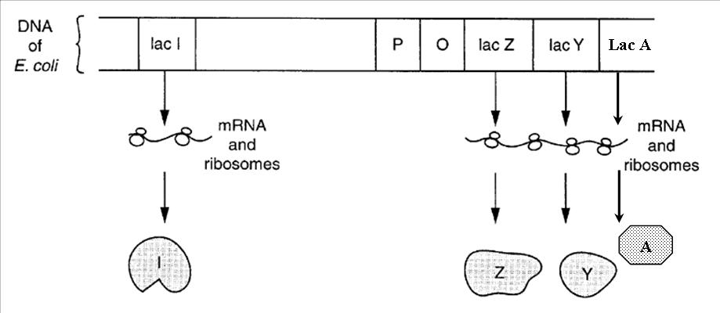  Fig. 3.1
 | (a) | With reference to Fig. 3.1, complete the table below.

 | Structure | Function
 | P |  binding site for RNA pol;
 | O |  binding site for repressor/ lacI protein;
 | Z |  cleaves lactose à glu + gal / change lactose à allolactose;
 | Y |  allows entry of lactose into bacteria;
 | A | detoxify metabolites of lactose metabolism;
 | I |  repressor protein to bind to operator;

 |  | [3]
Fig. 3.2 shows a diauxic growth curve of E. coli cultured in a medium with both glucose and lactose.

Growth () of bacteria is measured in terms of optical density (OD) at wavelength of 650nm, concentration of lactose () and glucose () are measured in millimolar (mM).

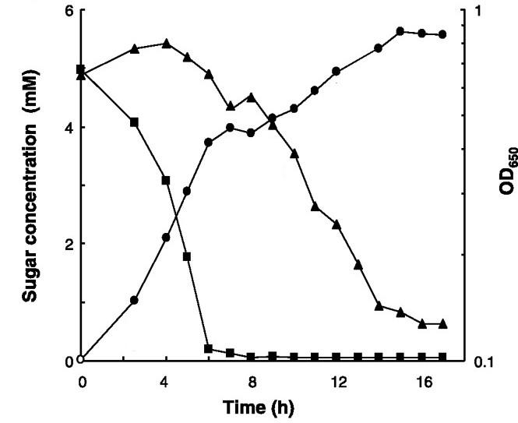

Fig. 3.2

 | (b) | With reference to Fig. 3.2, explain the bacteria growth rate
 | (i) | for the first 6 hours;
 |  | - growth á from 0 to ~ 0.4 utilising glucose as main resp substrate, concentration dropping from 5 to ~0.2mM;
 |  | - glu inhibits adenyl cyclase, preventing production of cAMP;;
 |  | - absence of cAMP-CAP cplx to bind to promoter of lac operon;; | [3]
 | (ii) | from 6 to 8 hours;
 |  | - growth plateaus at about 0.4, growth stops due to time lag in the expression of the lac operon;; | [1]
 | (iii) | from 8 hours onwards.
 |  | - Growth increases from 0.5 to 0.9, utilising lactose as the energy source, drops from 4.3 to 0.5mM;;
 |  | - β galactosidase converted lactose to inducer allolactose;
 |  | - binds to repressor protein, changes config, prevent binding to operator;;
 |  | - adenyl cyclase active, converting ATP to cAMP, cAMP binds to CAP,;;
 |  | - cAMP-CAP cplx binds to promoter, enhanced binding by RNA pol, expressing enz in lactose metabolism;; |  | [5]
 | (c) | Suggest reasons why prokaryotes regulate gene expression predominantly at the transcription level.
 |  | - more efficient to regulate at transcriptional level due to absence of nuclear membrane, allowing simultaneous transcription and translation;;
 |  | - mRNA production of a grp of genes in the same metabolic pathway controlled by one single operator, allows quick response to changes in ext env;; |  | [2]
 | (d) | Suggest the biological advantage of arranging genes in operons.
 |  | - genes under coordinate control, where one operator controls the access of RNA polymerase too several structural genes;; |  | [1]
 |  | [Total: 15]

4 | In disorders such as retinoblastoma, individuals inheriting one mutant allele of the RB1 gene can cause a predisposition to the development of eye tumours. For individuals to develop retinoblastoma, a somatic mutation in the other normal allele of the RB1 gene is necessary.
 | (a)(i) | Explain if the mutant RB1 allele causing retinoblastoma acts in a dominant or recessive manner.
 |  | - recessive;
 |  | - req both alleles to be mutated, indvl must be homozygous; | [2]
 | (ii) | Suggest how somatic mutation in the normal allele can occur.
 |  | - spontaneous / induced by chemical mutagen / radiation to cause base sub / del / insertion;
 |  | - mismatch bases due to failure in proofreading during replication; | [1]
The RB1 allele codes for the RB protein (pRB) which binds to a family of transcription factors called E2F. pRB binding inactivates E2F proteins. When pRB is phosphorylated by cyclin-CDK complexes, it releases bound E2F proteins resulting in the production of proteins involved in cell cycle progression to S phase through the cell cycle checkpoint. Fig. 4.1 shows the interaction between pRB and cyclin-CDKs.

Fig. 4.1

 | (b) | Describe how a mutation in the RB1 allele results in retinoblastoma.
 |  | - mutant RB1 with Δ in base seq leading to Δ in 1⁰ struct of pRB thus diff folding & 3D config;
 |  | - unable to bind E2F which becomes constitutively active;
 |  | - thus bind promoter to cause  expression of cell cycle prot protmoting progression thro S phase even in the absence of cyclin-CDKs leading to uncontrolled cell division; | [3]
receptor tyrosine kinase | pRB and cyclin-CDKs are involved in G₁ checkpoint which regulates cell division. The accumulation of cyclinE-CDK2 and cyclinD-CDK4 is due to the presence of growth factors.  Fig. 4.2 shows the cell signalling pathway at the G₁ checkpoint involving cyclinD, cyclinE and pRB.  growth factor  ras protein  relay protein  myc gene  cytosol  nucleus  increase in cyclin D  increase in cyclin E  increase in E2F  Fig. 4.2
 | (c)(i) | Describe how the presence of growth factors influences the progression of the cell cycle.
 |  | - GF binds RTK receptor causing conformational Δ leading to autophosphorylation of tyr tails;
 |  | - this activates ras prot which activates relay prot via phosphorylation cascade leading to signal amplification & transduction;
 |  | - activated TFs binds promoter of myc gene leading to  myc prot expression, ing pdtn of cyclins & E2F, cause cell to progress thro cell cycle; | [3]
 | (ii) | A mutation in the ras gene also brings about cancer. With reference to Fig. 4.1 and 4.2, explain why cancer is a multi-step process.
 |  | - need for mutation in > 1 gene to cause cancer;
 |  | - mutation in RB alone without  in E2F or cyclin  result in  in cell cycle prot, need ras to be mutated to  cyclin & E2F pdtn; or
 |  | - req loss-in-f(x) mutation in RB1 & gain-in-f(x) mutation in ras; | [2]
 | (iii) | State one other factor, besides the presence of growth factors, which influences the progression of the cell cycle through the G₁ checkpoint.
 |  | - DNA damage;
 |  | - cell size; | [1]
 |  | [Total: 12]

5 | Four different eye pigments in Drosophila are derived from the amino acid tryptophan. A simplified metabolic pathway of pigment production is shown in Fig. 5.1. Three different gene loci, V/v, C/c and B/b, are involved in this pathway, acting as shown in Fig. 5.1.  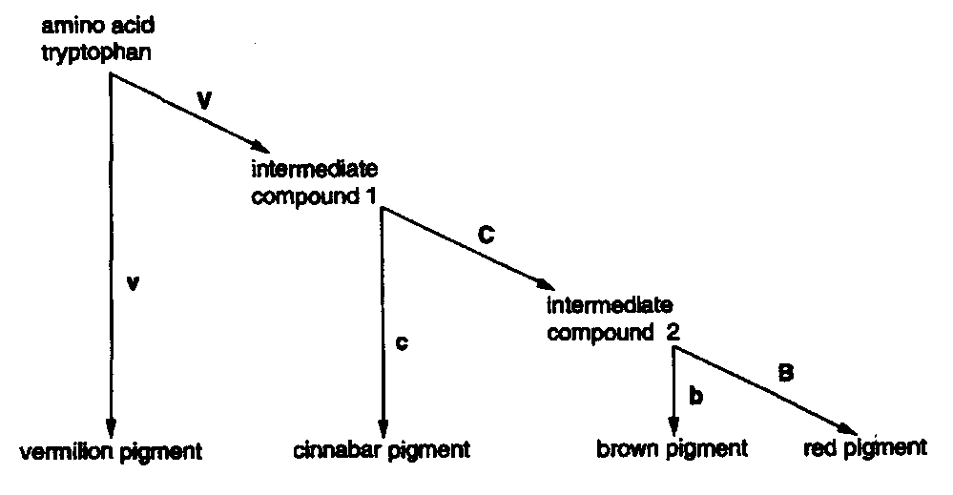  Fig. 5.1
 | (a)(i) | Using the information in Fig. 5.1, deduce the phenotypes of flies with the following genotypes: [1]
 |  | genotype | phenotype
 |  | VvCcBb | red eyed
 |  | VVCCBB | red eyed
 |  | VvccBB | cinnabar eyed
 | (ii) | Suggest an explanation for the gene interaction in the pathway of pigment production.
 |  | - genes code for prot / enz controlling / governing the same metabolic pathway / rxns leading to eye colour;
 |  | - product of 1 rxn acts as substr for the nxt rxn; |  |  |  |  |  | [2]
 | Pure-breeding red-eyed flies, CCBB were crossed with pure-breeding cinnabar-eyed flies, ccbb. Both sets of flies were homozygous dominant for the V/v locus. (You need not include this locus.) The F₁ were test-crossed (backcrossed) giving 32 red-eyed, 18 brown-eyed and 50 cinnabar-eyed flies.
 | (b) | Draw a genetic diagram in the space below to show the expected genotypes and phenotypes of the offspring of this test-cross, and state the ratio of phenotypes expected. (Take care that the symbols C and c cannot be confused in your answer.)  test cross CcBb x ccbb  gametes CB Cb cb (1m)  cB cb  Punnett Sq (1m)  Genotypic ratio  (1m)  Phenotypic ratio  [3]
 | (c)(i) | 36 of the cinnabar-eyed offspring in the test cross generation were pure-breeding. Perform a chi-squared test on the observed ratio of the test-cross. State the calculated χ² value. (Working is not required)  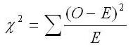
 |  | Calculated χ² value |  | 13.6 |  | [1]
 | (ii) | Using the χ² probabilities in Table 5.2, state what conclusions could be drawn from the calculated χ² value.  Table 5.2  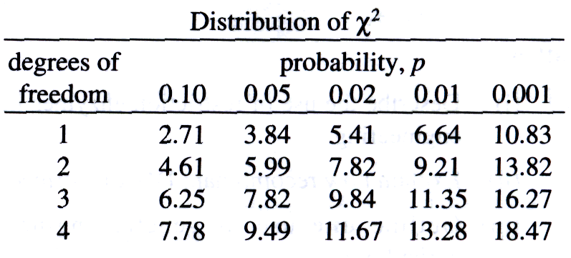
 |  | - χ²_{cal} > χ²_{(0.05, 3)}, 0.001 < p < 0.01,
 |  | deviation is not due to chance, C/c & B/b loci are linked; |  |  |  |  | [1]
 |  | [Total: 8]

6 | A suspension of mitochondria was isolated from liver tissue. Various substances were added to the suspension at different time intervals and the amount of oxygen remaining in the preparation was monitored over some time. Fig. 6.1 shows the results as well as the times at which different substances were added.  Amount of oxygen in the preparation  Respiratory substrate added  Time A: ADP added  Time B: ADP added  Time C: ADP added  Time  Fig. 6.1
 | (a)(i) | The respiratory added was found not to be glucose. Suggest a suitable substrate to be added to the mitochondria suspension.
 |  | pyruvate; | [1]
 | (ii) | Explain why glucose cannot be the respiratory substrate that was added.
 |  | inner mito mem not permeable to glc; | [1]
 | (b)(i) | Explain the change in the amount of oxygen between Time A and Time B.
 |  | - in the  of ADP, H⁺ accumulated in intermembranal space diffuses  conc. grad back to matrix via ATP synthase, phosphorylating ADP to ATP;
 |  | - this allows e-s to be trspt^{d} down ETC to finally reduce O2  H2O thus ing amt of O2;
 |  | - upon depletion of ADP, cessation of H+ flow leads to saturation of proton grad thus causing e- carriers to remain reduced, O2 levels remains constant; | [3]
 | (ii) | Account for the shape of the graph after Time C.
 |  | depletion of substr; | [1]
 |  | [Total: 6]
7 | Many of the body’s pain receptors stimulate sensory neurones that terminate in the grey matter in the spinal cord. Here, they synapse with relay neurones that transmit pain information to the sensory cortex of the brain. The activity of the relay neurones is influenced by inhibitory neurones that originate in the hind brain. These neurones terminate on the synaptic bulbs of the sensory neurones just before they synapse with the relay neurones. The inhibitory neurones release the neurotransmitter enkephalin, which fits into special receptors known as opiate receptors. Opiate drugs, such as morphine, can also occupy these sites and stimulate lengthy activation of these receptors. Fig. 7 shows the arrangement of the neurones concerned with pain reception.  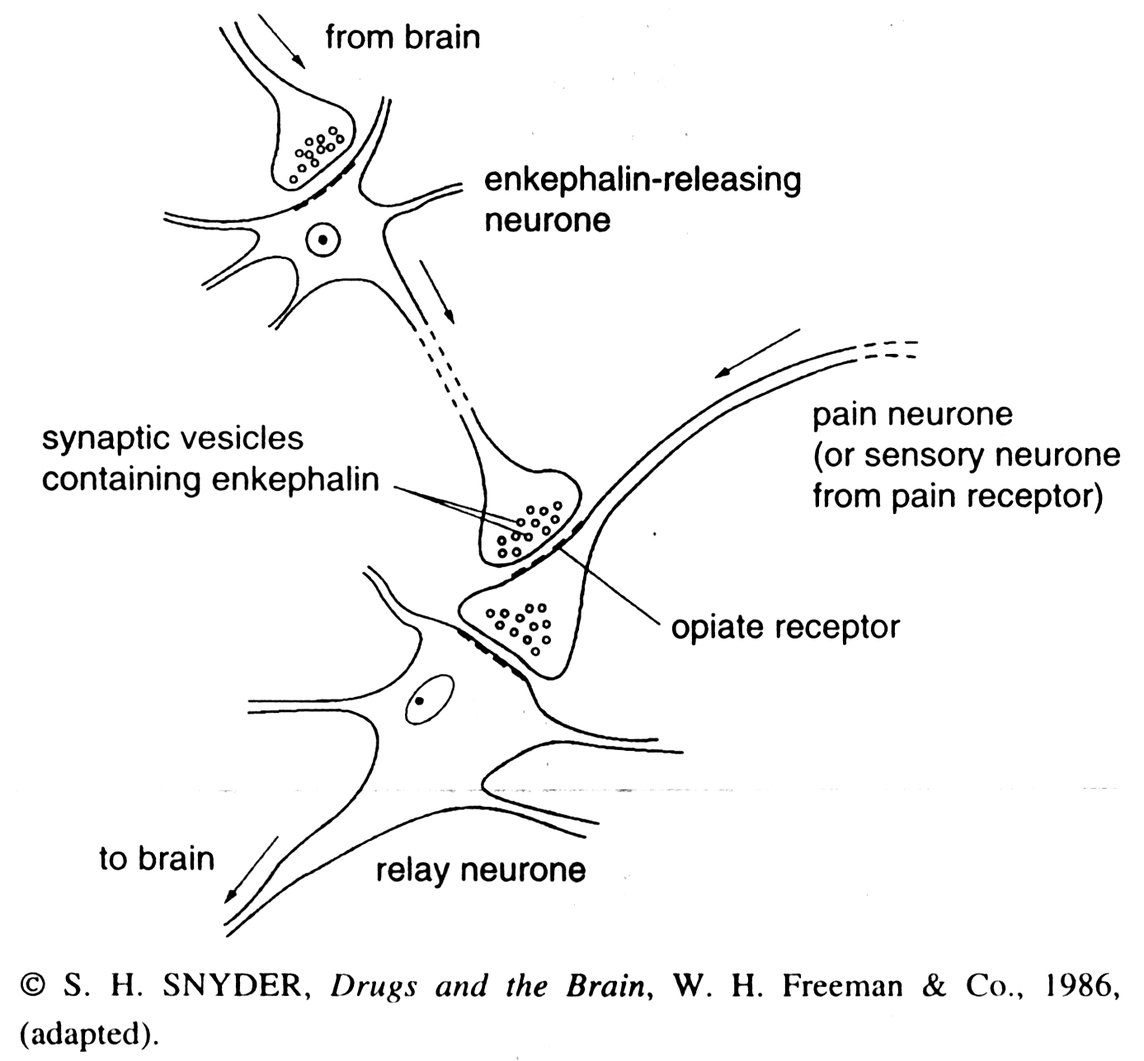  Fig. 7
 | (a) | Suggest possible mechanisms by which enkephalin-releasing neurones inhibit the passage of impulses to the brain.
 |  | - arrival of impulse fr brain cause neurone to release enkephalin which binds opiate receptors causing IPSP / opening of K⁺ or Cl⁻ channels;
 |  | - cause hyperpolarisation / efflux of K⁺ or influx of Cl⁻;
 |  | - impulse arriving at synaptic knob of pain neurone causes depolarisation < threshold thus no AP generated & impulse not transmitted aX synapse |  | [3]
 | (b) | Suggest why opiates stimulate lengthy activation of opiate receptors but enkephalin does not.
 |  | 1. no enz specific for opiate degradation;
 |  | 2. opiate with higher affinity for receptor / stronger bonds; |  | [1]
 | (c) | Explain why people addicted to opiates often experience severe pain as a withdrawal symptom.
 |  | - enkephalin pdtn reduces due to –ve feedback;
 |  | - upon opiate withdrawal, synaptic knob with insufficient enkephalin to inhibit pain; |  | [2]
 |  | [Total: 6]

8 | Table 8.1 shows the amino acid differences in the alpha haemoglobin chains between various vertebrates.

Table 8.1
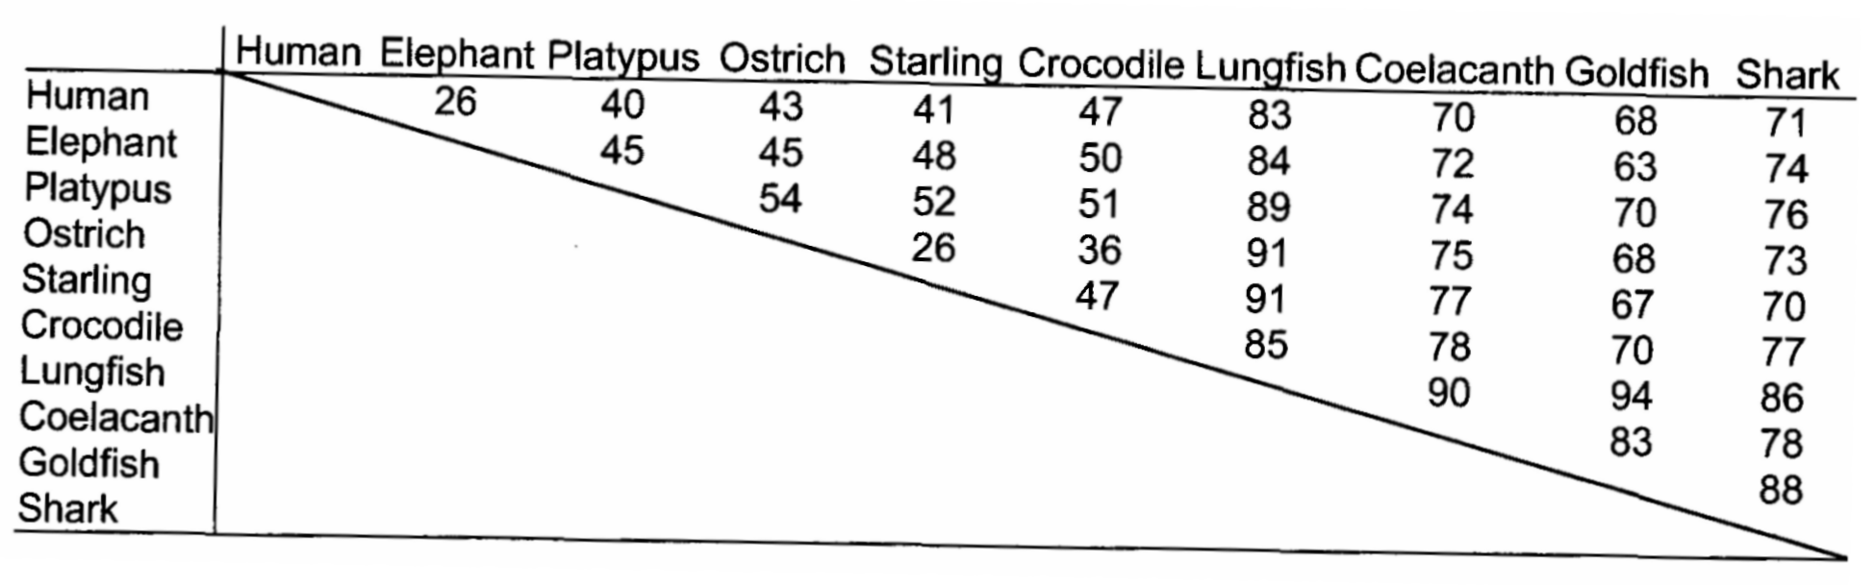

 | (a) | State what is meant by the term gene mutation.
 |  | - point mutation, Δ in base seq e.g. sub, del, insertion;
 |  | - resulting in missense, nonsense or frameshift; | [2]
 | (b) | Explain why some gene mutations do not result in a change in amino acid.
 |  | - single base sub at 3rd base of codon;
 |  | - results in degenerate code coding for the same aa due to wobble base phenomenon;
 |  | - silent mutation; | [3]
 | Fig. 8.2 shows a family tree based on differences between the alpha haemoglobins in Table 8.1

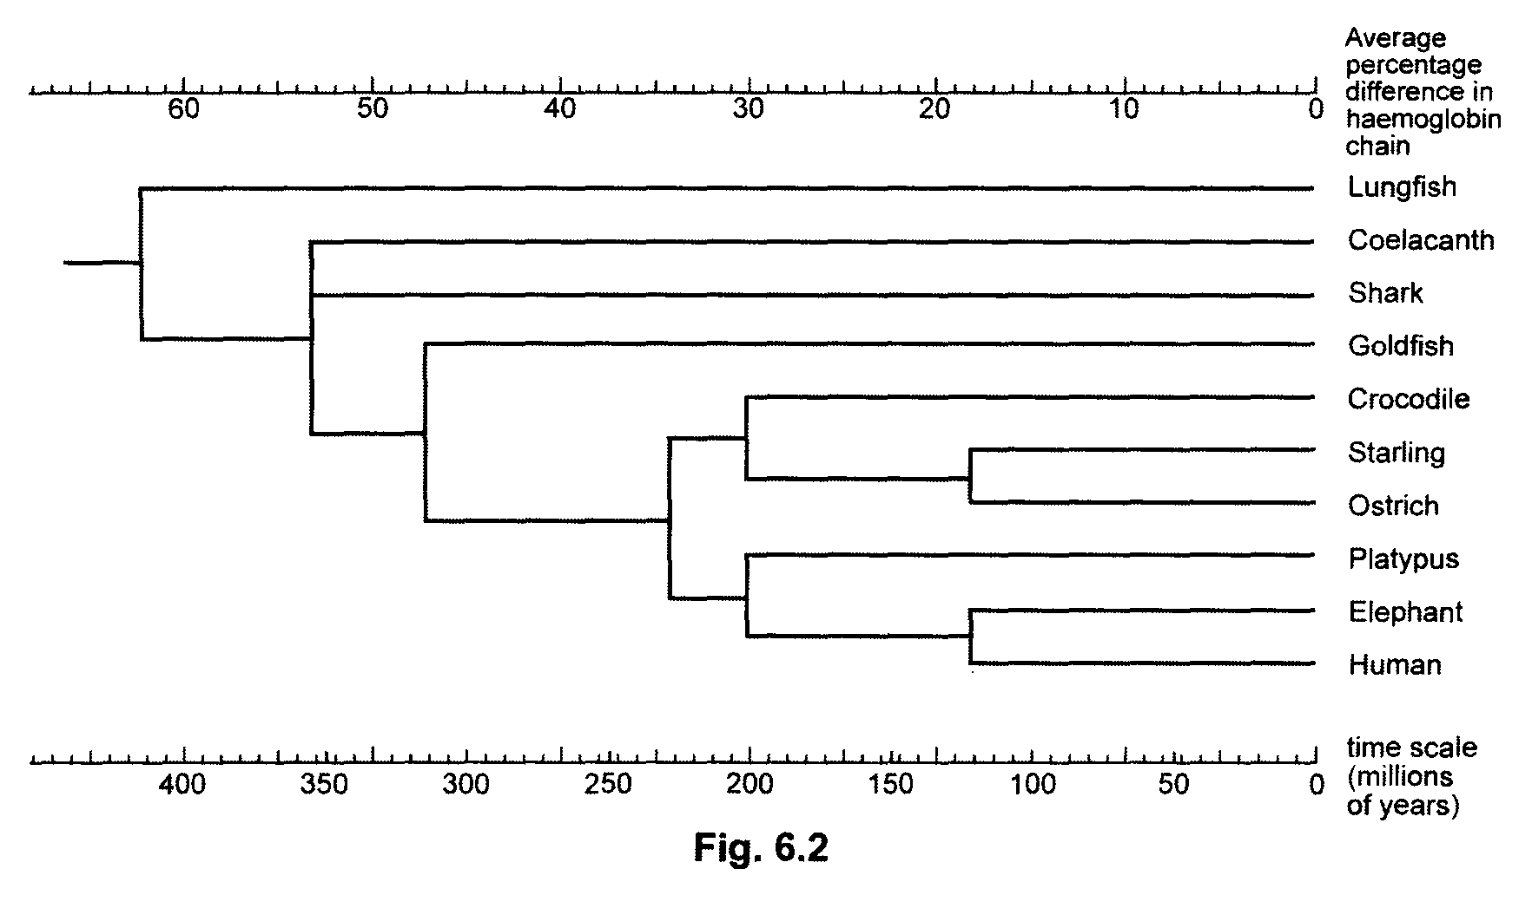

Fig. 8.2

 | (c) | Explain what direct evidence exists for the time scale in Fig.8.2.
 |  | - anatomical homology shown in fossil records with time indicated by carbon dating / rock stratification;
 |  | - molecular homology in DNA / aa seq with time indicated by molecular clock / constant mutation rate; |  |  | [2]
 | The gene for alpha haemoglobin is carried on chromosome 16 and contains three coding sections and two non-coding sections.
 | (d) | State the name given to
 | (i) | coding sections | exons
 | (ii) | non-coding sections | introns | [1]
Also on chromosome 16, there exist duplicated but non-functional pseudogenes, that resemble the functional gene but have some defect that renders them useless.

The rate of gene mutation in non-coding sections of genes and pseudogenes is very much faster than in the coding sections of genes.

 | (e) | Suggest why the apparent rate of accumulation of gene mutations in coding sections is slower.
 |  | mutations in non-coding regions  affect prot struct & are selectively neutral or … in coding regions leads to Δ in aa seq & are usu harmful / lethal;
 |  |  affect the survival of the organism carrying the mutaiton thus pass  to offspring, mutation persists in popn or organism with harmful / lethal mutation is naturally selected agst / die thus  pass on allele |  |  | [2]
 |  | [Total: 10]

9 | (a) | Describe the structure of DNA and its organisation in a eukaryotic chromosome. [8]
- 2 polymers of deoxyribonucleotides chains twisted into a double helix;;
- held by H- bonds between complementary bases, A=T, C≡G;;
- a. purine-pyrimidine: 2 nm diameter;
3. b. 0.34nm/10 bp per complete turn;;
- distinct polarity 3’ end with free hydroxyl group at 3C and 5’ end with phosphate group at 5C;;
- DNA molecule associated 1¾ turns with 8 histone proteins/octomer, formed nucleosome core;;
- histones positively charged, formed ionic bonds with negatively charged DNA;;
- associate with H1 histone to form nucleosome, linked by spacer/linker DNA forming 10nm ‘beads-on-string’ structure;;
- further coiled into a solenoid forming a 30nm fibre;;
- futher looping in presence of scaffold proteins to form metaphase chromosomes;;
- AVP;;

 | (b) | Describe the control of gene expression in eukaryotes. [12]
Gene Amplification
- duplication of genes to increase the number of copies;;
Chromatin remodelling
- acetylation removes +ve charges from histones, loosen –ve charged DNA, allow GTF to bind;;
- demethylation removes methyl grps from proximal promoters, e.g. CpG islands;;
Transcriptional control
- cis-acting elements, GTFs binding to promoters and proximal promoters;;
- binding of STF e.g. activators to enhancer, repressors to silencers á and â transcription rate;;
Post-transcriptional control
- ss pre-mRNA, with 5’ capping with modified guanine/methylated guanine;;
- 3’ polyadenylation for stability/ nuclear export of mature mRNA;;
- splicing of introns out and joining of exons forms mature mRNA by spliceosome;;
- association with proteins for nuclear export;;
- mRNA editing, the ∆ in codon results in different functional polypeptide;;
Translational control
- stability of mRNA in the cytoplasm controlled by degradation in response to presence of RNA sequence signalling degradation, concentration of the translated product, extracellular signals like hormones;;
- gene silencing by miRNA, forming complementary dsRNA in DICER cplx prevent ribosomal attachment/ cleave mRNA;;
Post-translational control
- proteins not required are tagged for ubiquination by protease;;
- AVP;;
 |  | [Total: 20]

10 | (a) | Explain the principles of homeostasis. [4]
- Homeostasis is the maintenance of a constant, stable internal environment within an organism regardless of changes in external environment via a self-regulating mechanism;;
- The regulated variable is usually at a set point which can be changed by a stimulus;;
- change detect by a receptor which sends signals to control center/regulator;;
- activates effector resulting in a response to restore set point via positive/negative feedback;;

 | (b) | Describe the roles of insulin and glucagon in regulation of blood glucose. [10]
Insulin
- [bld glu] á above norm, β cells in islets of Langerhans detect the á;;
- insulin released to bind to rtk receptors of effectors e.g. liver cells;;
- results in increased no. of glucose transporters in the liver cells to increase uptake of glucose;;
- convert excess glucose to glycogen in glycogenesis by activating glycogen synthetase;;
- Depresses rate of synthesis of glucose from non-carbohydrate source via gluconeogenesis;;
Glucagon
- [bld glu] â below nom, α cells in islets of Langerhans detect the drop;;
- glucagons released bind to GPCR on effector e.g. liver cells;;
- results in activation of glycogen phosphorylase to convert glycogen into glucose;;
- reached set point, neg feedback mechanism prevents further release of hormones by pancreas;;
- AVP

 | (c) | Describe the molecular events when glucagon binds to its target cell. [6]
- Glucagon binds to the complementary ligand-binding site on GPCR receptor causing a conformational change to receptor;;
- GTP from the cytosol then displaces GDP from the nucleotide-binding site on G_{α};;
- G_{α} simultaneously dissociates from its G_{βγ}, translocate along the plasma membrane to activate the enzyme adenylyl cyclase;;
- Adenylyl cyclase catalyses the conversion of ATP to cyclic AMP (cAMP);;
- cAMP activate relay protein, protein kinase A (PKA);;
- Activated PKA then phosphorylates other relay proteins and enzymes, activates other enzymes in phosphorylation cascade;;
- The effect of cAMP is removed by phosphodiesterase which converts cAMP back to AMP;;
- AVP;;
 |  | [Total: 20]

